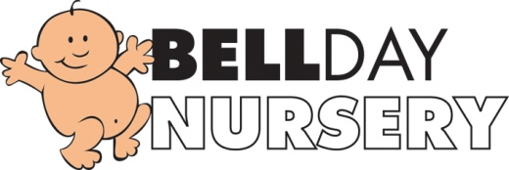
Policy on Biting
Biting can be an uncomfortable subject for parents of both the biter and the child who is bitten. We hope that this policy will explain how we deal with biting in the Nursery. Please do discuss any concerns you may have regarding this issue with us. If your child is known to bite, we would prefer to know in advance.
Children bite for a variety of reasons. This may be because they are teething, frustrated, exploring using their mouth, asserting their independence and wanting to gain control, maybe of a toy or they could be stressed. It may also be because they want to gain attention.
We will work with you and your child to establish when why they are biting. We will observe the child closely to see if certain conditions or situations trigger the behaviour and then work with them to try and avoid the incidents occurring. This may involve altering the child’s routine, giving them more one to one attention, purchasing additional resources so sharing is not such a major issue or if it is because a child is teething provide suitable teething resources.
We will ensure that if a child is bitten that they are comforted and given lots of attention. We will ensure that any first aid is applied correctly if required and the incident will be recorded in our book and parents asked to sign it.
If your child bites, then we will remove them from the situation. We will explain to them, according to their age and understanding that biting is unacceptable behaviour. For a younger child this may be our tone of voice and facial expressions rather than lots of words. It may be necessary for us to exclude the child from an activity until they calm down. We will also encourage the child to apologise to the child they have bitten and work with them to develop strategies to help them deal with the reasons.
Many children go through a stage of biting, please do not be alarmed; it does not last forever.

Reviewed September 2019
Signed: G. Owers

