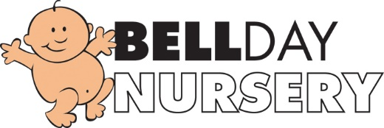

Bell Day Nursery Allergy policy
At Bell Day Nursery, we are aware that children can have allergies which may cause allergic reactions. We will follow this policy to ensure allergic reactions are minimised or where possible prevented and staff are fully aware of how to support a child who may be having an allergic reaction.

- Staff will be made aware of the signs and symptoms of a possible allergic reaction in case of an unknown or first reaction in a child. These may include a rash or hives, nausea, stomach pain, diarrhoea, itchy skin, runny eyes, shortness of breath, chest pain, swelling of the mouth or tongue, swelling to the airways to the lungs, wheezing and anaphylaxis.
- Information will be passed on by parents from the registration form and home visit regarding allergic reactions and allergies and must be shared with all staff in the nursery. All information will be kept on the child’s Famly account.
- An allergy register will be kept in the manager’s office and kitchen.
- The nursery manager must carry out a full Allergy Risk Assessment Procedure with the parent prior to the child starting the nursery. The information must then be shared with all staff.
- All food prepared for a child with a specific allergy will be prepared in an area where there is no chance of contamination and served on equipment that has not been in contact with this specific food type, e.g. nuts .
- The manager, nursery cook, and parents will work together to ensure a child with specific food allergies receives no food at nursery that may harm them. This may include designing an appropriate menu or substituting specific meals on the current nursery menu.
- If a child has an allergic reaction to food, a bee sting, plant etc. a first aider will act quickly and administer the appropriate treatment. Parents must be informed, and it must be recorded in the incident book.
- If this treatment requires specialist treatment, e.g. an EpiPen, then at least two members of staff working directly with the child and the manager will receive specific medical training to be able to administer the treatment to each individual child.
- A sick child above all needs their family; therefore, every effort should be made to contact a family member as soon as possible.
- If the allergic reaction is severe a member of staff will summon an ambulance immediately.
- Whilst waiting for the ambulance, we will contact the emergency contact and arrange to meet the parent/carer at the hospital.
- A senior member of staff must accompany the child and collect together registration forms, relevant medication sheets, medication and child’s comforter and any relevant information.
- Staff must remain calm always; children who witness an allergic reaction may well be affected by it and may need lots of cuddles and reassurance.
- All incidents will be recorded, shared and signed by parents at the earliest opportunity.
- Our Nursery Chefs have completed online Allergy Awareness Courses and a number of our practitioners have completed Epi-Pen training.
May 2019 Reviewed September 2020 Reviewed and updated: July 2021 Signed: G.Owers

