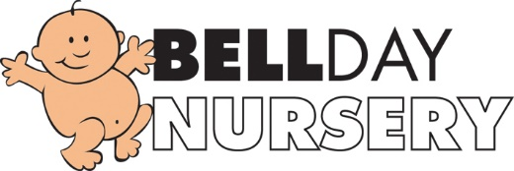
Non-Payment of Fee’s Policy
Fees are payable by cheque, vouchers or BACS payment on your child’s first session each month.

If an account is not paid during this week the nursery reserves the right to suspend the place until the payment is made (the suspended place will only be held for 1 month from the date of the overdue bill).

If there are any individual issues concerning family’s, management will discuss this and support where possible.

September 2019
Reviewed: July 2020
Signed: G.Owers

