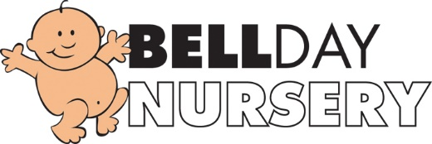

Epidemic and Pandemic Policy

The health and wellbeing of children, staff and parents is of paramount importance at Bell Nursery.
In cases of possible pandemic/epidemics we will monitor the situation daily and follow the advice given by the government and health authority. If a person is found to be infected, we will close the nursery and follow government advice on deep cleaning and isolation times. We will keep parents informed via Famly if we must close the nursery and details of how long we will remain shut.
We ask all parents to keep their child at home if they have fever, cough or flu like symptoms that may be associated with the current outbreak. We ask that if your child is asked to go for a Covid PCR test that you send through the results as soon as you receive them to helebdn@outlook.com .We will also request from parents follow government guidelines when returning from travel abroad.
We provide hand anti bac gels at entry/exit points for parents and the children wash their hands on arrival before entering the premises.
We encourage staff and children to have exceptionally high standards of personal hygiene to limit the spread of infection.

Policy adopted on 10th March 2020.
Review date 10th March 2021.
Reviewed and Updated: July 2021

