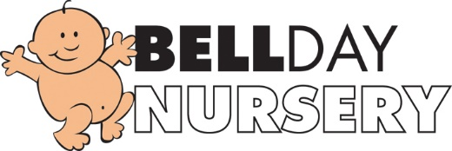
Non-Payment of Fee’s Policy
Fees are payable by BACS or Childcare vouchers during the first week of each month.

If an account is overdue by two months the nursery reserves the right to suspend the place until the payment is made (the suspended place will only be held for 1 month from the date of the last overdue bill).

If there are any individual issues concerning payments management will discuss this and support where possible.

September 2019
Reviewed: July 2020
Reviewed and Updated: July 2021
Signed: G.Owers

