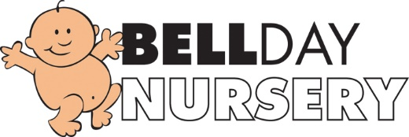

Epidemic and Pandemic Policy

The health and wellbeing of children, staff and parents is of paramount importance at Bell Nursery.
In cases of possible pandemic/epidemics we will monitor the situation daily and follow the advice given by the government and health authority. If a person is found to be infected, we will close the nursery and follow government advice on deep cleaning and isolation times. We will keep parents informed via Famly/Classdojo if we have to close the nursery and details of how long we will remain shut.
We ask all parents to keep their child at home if they have fever, cough or flu like symptoms that may be associated with the current outbreak. We will also request from parents follow government guidelines when returning from travel abroad.
We provide hands gels at entry/exit points for parents and children's use.
We encourage staff and children to have exceptionally high standards of personal hygiene to limit the spread of infection.

Policy adopted on 10th March 2020.
Review date 10th March 2021.

